**Exercise 6: Cursors**

**Scenario 1:** Generate monthly statements for all customers.

* + **Question:** Write a PL/SQL block using an explicit cursor **GenerateMonthlyStatements** that retrieves all transactions for the current month and prints a statement for each customer.

**Scenario 2:** Apply annual fee to all accounts.

* + **Question:** Write a PL/SQL block using an explicit cursor **ApplyAnnualFee** that deducts an annual maintenance fee from the balance of all accounts.

**Scenario 3:** Update the interest rate for all loans based on a new policy.

* + **Question:** Write a PL/SQL block using an explicit cursor **UpdateLoanInterestRates** that fetches all loans and updates their interest rates based on the new policy.

**Scenario 1**

DECLARE

CURSOR c_monthly_transactions IS

SELECT t.TransactionID, t.AccountID, t.TransactionDate, t.Amount, t.TransactionType, a.CustomerID

FROM Transactions t

JOIN Accounts a ON t.AccountID = a.AccountID

WHERE EXTRACT(MONTH FROM t.TransactionDate) = EXTRACT(MONTH FROM SYSDATE)

AND EXTRACT(YEAR FROM t.TransactionDate) = EXTRACT(YEAR FROM SYSDATE);

v_customer_id Accounts.CustomerID%TYPE;

v_transaction_id Transactions.TransactionID%TYPE;

v_account_id Transactions.AccountID%TYPE;

v_transaction_date Transactions.TransactionDate%TYPE;

v_amount Transactions.Amount%TYPE;

v_transaction_type Transactions.TransactionType%TYPE;

BEGIN

OPEN c_monthly_transactions;

LOOP

FETCH c_monthly_transactions INTO v_transaction_id, v_account_id, v_transaction_date, v_amount, v_transaction_type, v_customer_id;

EXIT WHEN c_monthly_transactions%NOTFOUND;

DBMS_OUTPUT.PUT_LINE('Customer ID: ' || v_customer_id);

DBMS_OUTPUT.PUT_LINE('Transaction ID: ' || v_transaction_id);

DBMS_OUTPUT.PUT_LINE('Account ID: ' || v_account_id);

DBMS_OUTPUT.PUT_LINE('Transaction Date: ' || v_transaction_date);

DBMS_OUTPUT.PUT_LINE('Amount: ' || v_amount);

DBMS_OUTPUT.PUT_LINE('Transaction Type: ' || v_transaction_type);

DBMS_OUTPUT.PUT_LINE('---------------------------------------');

END LOOP;

CLOSE c_monthly_transactions;

END;

/

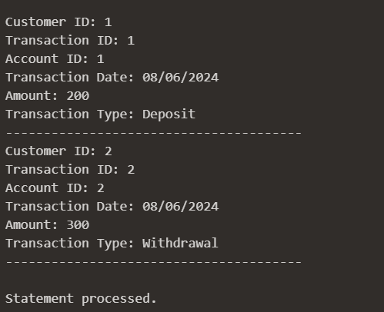

**Scenario 2**

DECLARE

CURSOR c_accounts IS

SELECT AccountID, Balance

FROM Accounts;

v_account_id Accounts.AccountID%TYPE;

v_balance Accounts.Balance%TYPE;

annual_fee NUMBER := 100;

BEGIN

OPEN c_accounts;

LOOP

FETCH c_accounts INTO v_account_id, v_balance;

EXIT WHEN c_accounts%NOTFOUND;

UPDATE Accounts

SET Balance = v_balance - annual_fee

WHERE AccountID = v_account_id;

END LOOP;

CLOSE c_accounts;

COMMIT;

END;

/

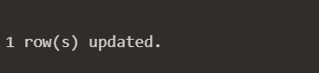

**Scenario 3**

DECLARE

CURSOR c_loans IS

SELECT LoanID, InterestRate

FROM Loans;

v_loan_id Loans.LoanID%TYPE;

v_current_interest_rate Loans.InterestRate%TYPE;

new_interest_rate NUMBER;

BEGIN

OPEN c_loans;

LOOP

FETCH c_loans INTO v_loan_id, v_current_interest_rate;

EXIT WHEN c_loans%NOTFOUND;

new_interest_rate := 6;

UPDATE Loans

SET InterestRate = new_interest_rate

WHERE LoanID = v_loan_id;

END LOOP;

CLOSE c_loans;

COMMIT;

END;

/

